Pressure Gauge and Thermocouple monitoring device specification/User guide.

# Main Purpose

The device can connect to gauge controllers (Both 937A and 937B), other gauges and thermocouples in order to display and log the pressures/temperatures of the connected devices. The associated companion program also exports the logged data for review/analysis later and graphs it.

# Hardware

## Inputs

There are 6 total inputs:

* 2 Gauge controller ports
* 2 Active gauge ports
* 2 Thermocouple ports

(The Gauge controller ports need an external adapter to allow for the use of both 937A and 937B gauge controllers and other gauges.)

### Gauge Controllers

#### 937A

The 937A Controller has a 25 pin analogue output that will be used by the device. Its output pins functions are as follows:

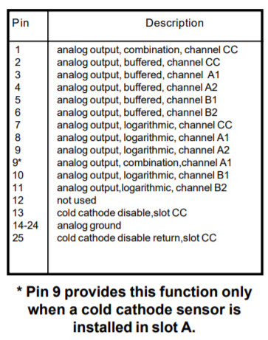

Figure : Pin configuration for the 937A Gauge controller’s analogue output

Here the main pins in use will be the logarithmic output channels for all of the connected gauges. This is pins 7,8,9,10,11. These output a 0 – 10 V signal which can be used in combination with the equations:

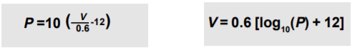

Equation

Note: In the pressure equation it is 10 raised to the power of the bracket and in these equation V is in volts and P is in Torr. These are used to determine the pressure being measured by the gauge irrespective of gauge type.

Additionally the output may be something different if there is a fault with the connected gauge or if the pressure is outside the gauges measuring capacity. These value are given in the table below:

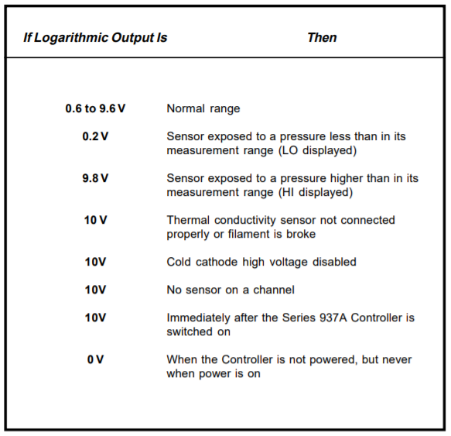

Figure : Logarithmic voltage output signals description

#### 937B

The 937B gauge controller uses a 37 pin analogue output that will be used by the device. Its pins function are listed in the table below:  
Here the main pins in use will be the logarithmic output channels for all of the connected gauges. This is pins 7,8,9,10,11,12. These output a 0 – 10 V signal which by default can be used in combination with equation 1 to calculate the measured pressure of the gauges.

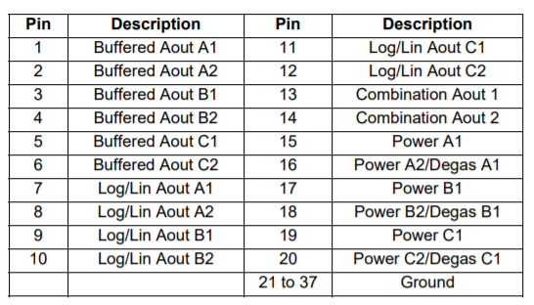

Figure : Pin configuration for the 937B Gauge controller’s analogue output

#### Connector / Adapter

The device uses up to 2, 37/25 pin to 9 pin cable, preserving the required pins (As detailed above) and using the remaining pins to provide ground.

### Other Gauges

TO ADD

### Thermocouples

The thermocouple measuring is handled by two MAX31855 thermocouple to digital amplifiers. These chips take in the thermocouple voltage and output the corresponding temperature, as they have inbuild adcs. This chip has a resolution of ~0.25°C for all thermocouples which are not type K, and ~2°C resolution for K types. This output is done on an SPI line and is read only, the chip is constantly converting the connected thermocouples temperature but only outputs it on the data line when prompted.

## Processing

### ADC

The analogue inputs are connected to two separate ADCs which then send the result to the microprocessor. The ADC in use is the ADS8332, which has 8 input channels and a resolution of 16 bits. This is run using a 3.3V power input for digital conversion and 5V input for analogue power, both supplied from the microcontroller. It also has an external reference voltage of 4.096V supplied by a reference ic, which in turn is supplied 5V from the microcontroller. The analogue inputs are put through a potential divider to reduce their voltage range from 0-10V to ~0-4V as the ADC can only work with voltages up to its reference voltage. This potential divider includes a smoothing capacitor.

The ADCs are connected to the microcontroller via SPI lines. The SPI lines consist of:

* SCLK: Serial Clock (output from master)
* MOSI: Master Out Slave In (data output from master)
* MISO: Master In Slave Out (data output from slave)
* CS /SS: Chip/Slave Select (often active low, output from master to indicate that data is being sent)

### Microcontroller

The microcontroller being used is the ATSAMD21G18A-MU which is mounted on a Seeduino Xiao board. This is connected to both of the ADC’s and Thermocouple amplifiers via SPI lines, with each component having an individual CS line and sharing the other 3 lines between all chips.

## Output

### Serial

The Seeduino Xiao has a USB type c port which can be used both for power and serial data transfer, through this port the Seeduino is both initially programmed and can send/receive serial data from a computer. When requested by the companion program for the device the Seeduino will send its latest readings to the program to be displayed.

## Power

All of these parts are powered from the USB input on the Seeduino Xiao board. According to USB power outputs (between 0.5 and 1.5A depending on the USB type leading to between 2.5 and 7.5W as USB runs at 5V) and the parts datasheets, the power input from the USB port should be enough to run all of the parts without an external battery.

## Part Links

Seeduino Xiao

Part/Information: <https://wiki.seeedstudio.com/Seeeduino-XIAO/>

ADC, ADS8332

Part: <https://www.digikey.co.uk/product-detail/en/texas-instruments/ADS8332IBPWR/296-42323-1-ND/5356909>

Datasheet: <https://www.ti.com/lit/ds/symlink/ads8332.pdf?HQS=dis-dk-null-digikeymode-dsf-pf-null-wwe&ts=1626687364148&ref_url=https%253A%252F%252Fwww.digikey.co.uk%252F>

Thermocouple Amplifier, MAX31855KASA+

Part: <https://uk.rs-online.com/web/p/instrumentation-amplifiers/1901414/>

Datasheet: <https://docs.rs-online.com/bfb9/0900766b813d54ca.pdf>

# Software

## Connection

The software accompanying the device will be able to automatically detect which port the device is connected to and communicate with it. It will also be able to ascertain what external inputs are connected to the device (i.e. a gauge controller or a thermocouple). For gauge controllers this can be done with the help of figure 2, which details specific output voltages for the logarithmic channels with meaning beyond the gauges reading.

## Device I/O

The software will also be able to request readings from the device at a user controlled rate. This will involve both setting the rate that the device is taking readings and also how often the software requests one over the usb connection.-

## Processing

The readings the software obtains will be converted into the correct form, so for gauge controllers equation 1 will be used on the voltage obtained and a conversion to mBar performed. These values are then stored in internal list variables and plotted on a real time graph.

## Exporting

The data the software has already gathered can then at any time be exported into a csv file, formatted such that each line contains a csv string for one of the external devices connected.